**Design and Comparison of Solar Thermal Oilfield Steam Production System Plans**

Cheng Zhang1, a) Yanping Zhang2, b) and Shuhong Huang2, 3)

1 School of Energy and Power Engineering, Huazhong University of Science and Technology   
2School of Energy and Power Engineering, HUST, Wuhan, China

3China-EU Institute for clean and Renewable Energy, HUST, Wuhan, China

a)Corresponding author: hustquick@hust.edu.cnb)zyp2817@hust.edu.cn

**Abstract.** Parabolic trough solar concentrating technology is a new and clean way to replace the conventional fossil fuel technology to generate steam for heavy oil recovery in oilfield. It is necessary to assess the feasibility and economic of the new technology before its implement. In this paper, according to the scheme and characteristic of steam loads, several plans for solar thermal oilfield steam production system are presented. A computational model which contains direct solar radiation calculation part, optical efficiency calculation part, and heat transfer calculation part was established and verified. Different plans were designed by the model, such as with single- and dual-loop, with and without heat storage system. Finally, different plans with different collector field layouts were compared by the cost of unit generated steam. Results show that using heat storage can effectively improve the stability of steam production, and for a certain oilfield, optimum steam production amount and optimum heat storage time exist for least steam cost. The methods and results in the paper can provide useful suggestions for the implementation of the solar thermal oilfield steam production system.

# Introduction

With the depletion of conventional-oil resources, heavy oil production becomes increasingly important for the vast reserves available worldwide. Heavy oil accounts for approximately 15% of the world’s petroleum resources. Karamay Oilfield is the largest heavy oil reservoir in China, its production has accounted for one third of the crude oil production. Thermal methods such as steam assisted gravity drainage, vapor extraction and steam injection are widely used in heavy oil production processes. For steam assisted gravity drainage, steam is continuously injected through the upper wellbore, softening bitumen so that it drains into the lower wellbore and is pumped to the surface.

Nowadays, fuel or gas-fired boilers are used to meet the needs of steam generation for oilfield, which lead to environmental problems and high oil production cost. With increasing awareness of energy conservation and environment protection, more clean methods can be applied for steam production.

Solar thermal technology is a clean technology using solar energy. Solar concentrating technologies such as parabolic trough, dish and Scheffler reflectors can provide heat for commercial and industrial applications. Among them parabolic trough, with low cost and mature development, is widely applied. Using parabolic trough to generate steam without generating sets is applicable to achieve much higher solar energy utilization efficiency with low cost.

Karamay is located in northwest China, it has abundant solar radiation resource, with global horizontal irradiation (GHI) about 1500kWh/(m2·a). The oilfield has lots of space for solar mirror field. So it is feasible to use solar thermal oilfield steam production system for heavy oil production. Its principle is using the trough mirror to converge the sunlight to the receiver to heat water to steam.

To apply solar thermal oilfield steam production system, different plans must be designed and compared. To design different schemes of system, computational models are built for direct solar radiation, optical efficiency and thermal efficiency.

# Computational Model

## Climate

Solar radiation is the only source of energy for solar collectors, solar radiation parameters are very important for the thermodynamic calculation of solar thermal oilfield steam production system. The amount of solar radiation of Karamay is key for design and comparison of the systems. In addition, the weather conditions of Karamay, especially temperature and wind speed, will have impacts on the systems.

To build the climate model, we need to get the data of solar radiation, temperature and wind speed.

### Solar Radiation

Karamay has abundant solar energy resource, with high solar radiation intensity and long duration of sunshine. No meteorological radiation test site is set in Karamay and its surrounding 100km area, so there are no corresponding meteorological radiation data in CMA (China Meteorological Administration) database. The amount of solar radiation in Karamay can be calculated by using ambient temperature and relative humidity data provided in CMA as Dimas Firmanda did. But the method does not take full account of local climate, such as clouds and air transparency. Angstrom pointed out that the ratio between monthly solar radiation reaches the ground and extraterrestrial solar radiation has a good linear relationship with monthly percent of sunshine. That means

 (

*Q* is the monthly solar radiation reaches the ground, *Q’* is the extraterrestrial solar radiation, *s* is the monthly percent of sunshine, *a* and *b* are empirical coefficients. For similar climate areas, *a* and *b* are the same.

Measured solar radiation data from other cities with similar climate in Xinjiang are used to calculate the approximate amount of solar radiation in Karamay. The meteorological radiation data of Urumqi and Tacheng are used, they belong to the same dried monsoon climate. Urumqi is located at about 300km southeast of Karamay, and Tacheng is located at about 240km northwest of Karamay. In a same area, the amount of solar radiation in a year is constantly changing, yearly average solar radiation data do not take considerations of some impact factors, so monthly average solar radiation data are used for estimation.

Using the measured solar radiation data, *a* and *b* in UKT (Urumqi-Karamay-Tacheng) area can be obtained of each month of a year. The monthly value of *s* of Karamay is approximately calculated by the value of Urumqi and Tacheng by their location (only considered the latitudes of the three cities). Then the linear coefficient α of monthly average radiation of Karamay and Urumqi of each month of a year can be obtained by using the existing data in CMA, so that in the future Karamay solar radiation can be calculated by record Urumqi solar radiation data.

 (

So we can get the *i*th month average radiation of Karamay

 (

Where, *i* = 1,2, ...12, *Qk,i* is the *i*th month average solar radiation of Karamay, *Qu,i* is the *i*th month average solar radiation of Urumqi.

Table 1 shows the results of correction coefficients of different months. From this table, monthly average solar radiation of Karamay can be calculated by that of corresponding month of Urumqi.

**TABLE 1. Correction coefficients of different months**

|  |  |  |  |  |  |  |
| --- | --- | --- | --- | --- | --- | --- |
| Month (*i*) | 1 | 2 | 3 | 4 | 5 | 6 |
| α*i* | 1.1989 | 1.2 | 1.1902 | 1.0433 | 1.036 | 1.0627 |
| Month (*i*) | **7** | **8** | **9** | **10** | **11** | **12** |
| α*i* | 1.1236 | 1.0468 | 1.0188 | 1.001 | 1.102 | 1.1199 |

### Temperature and Wind Speed

Temperatures of Karamay in 2012 and 2013 are listed in Table 2. In which, *Tav* means average temperature of the month, *Tav,h* means average high temperature of the day, *Tav,l* means average low temperature of the day, *Th* means highest temperature of the day, *Tl* means lowest temperature of the day. From the table, it can be found that Karamay has relatively large diurnal temperature difference. Heat loss of the system will differ a lot from day to night.

Karamay’s windy climate may bring some disadvantages for the solar thermal oilfield steam production system. High speed wind may destroy the structure of the system, especially the collector part. Dust rolled by strong wind may cause mirror wear and reduce light transmission. Wind will cause higher convection losses of pipes. These will affect the thermal efficiency of the system.

Wind speed data of Karamay can be found in CMA database. It can be found that maximum speed wind occur more often in spring, the reinforce work requires to be checked in springs.

### Optical Efficiency

Optical efficiency determines the amount of radiant energy reach on the receiver. Collector optical loss relates to site location, solar azimuth, and position, size, material of collector. Optical efficiency *ηopt* can be calculated by



**TABLE 2.** Temperatures in Karamay (°C)

|  |  |  |  |  |  |  |
| --- | --- | --- | --- | --- | --- | --- |
| **Year** | **Month** | ***Tav*** | ***Tav,h*** | ***Tav,l*** | ***Th*** | ***Tl*** |
| 2012 | 1 | -13.1 | -9.8 | -15.6 | 3.9 | -27.8 |
| 2012 | 2 | -14.5 | -10.6 | -17.3 | 2.1 | -25.5 |
| 2012 | 3 | -4 | 0.5 | -7.9 | 11.4 | -19.3 |
| 2012 | 4 | 10.4 | 16.1 | 5.3 | 30.7 | -4.9 |
| 2012 | 5 | 19.4 | 25 | 14.2 | 33.1 | 6.8 |
| 2012 | 6 | 25.9 | 31.9 | 20.7 | 40.7 | 13.2 |
| 2012 | 7 | 26.8 | 32.5 | 22.1 | 37.8 | 15.5 |
| 2012 | 8 | 25.7 | 31 | 20.5 | 36.9 | 15.5 |
| 2012 | 9 | 20.3 | 25.9 | 15.3 | 35.4 | 9.7 |
| 2012 | 10 | 11 | 16 | 7.5 | 26.7 | 1 |
| 2012 | 11 | 2.2 | 6.6 | -0.8 | 16.4 | -10.6 |
| 2012 | 12 | -9.8 | -6 | -12.4 | 6.5 | -21.5 |
| 2013 | 1 | -23.1 | -19 | -26.1 | -13.3 | -31.7 |
| 2013 | 2 | -9.4 | -5.8 | -12.7 | -2 | -23.9 |
| 2013 | 3 | -4.5 | 7 | -8.8 | 14.8 | -22.3 |
| 2013 | 4 | 15.9 | 21.6 | 11.1 | 30.3 | -1.9 |
| 2013 | 5 | 19.4 | 25.1 | 14.2 | 33.8 | 8.3 |
| 2013 | 6 | 26 | 31.5 | 20.9 | 36.2 | 17.2 |
| 2013 | 7 | 27.9 | 34 | 22.3 | 41 | 17.8 |
| 2013 | 8 | 25.7 | 31.6 | 20.6 | 37.1 | 13.7 |
| 2013 | 9 | 20.4 | 25.9 | 15.3 | 32.4 | 7.7 |
| 2013 | 10 | 11.3 | 16.3 | 7.6 | 27.9 | -1.4 |
| 2013 | 11 | 2.1 | 4.8 | -0.1 | 11.1 | -4.3 |
| 2013 | 12 | -11.6 | -8.1 | -13.9 | 3 | -23.2 |

Where, *ηendloss* is the end loss efficiency of the receiver. Fig. 1 shows the principle of it. When the incidence angle *θ* is not 0, there will be one end without concentrated solar energy, which causes end loss. End loss can be calculated as

 (

Where, *f* is the focal distance of the collector, *L* is the length of the collector. *ηshadow* is the shadow loss efficiency, Fig. 2 shows the principle of it. The shadow loss can be calculated as

 (

Where *Lspace* is the line spacing of collectors, *W* is the aperture width of collector.

|  |  |
| --- | --- |
| **FIGURE 1.** Principle of end loss | **FIGURE 2.** Principle of shadow loss |

*ηiam* is the incidence angle loss efficiency. For various types of solar trough collectors, the reflectivity and absorptivity of the glass envelope increase with incidence angle. IAM is the incidence angle modifier, which is used to correct the reflectivity and absorptivity influenced by incidence angle. It is related to the collector type and material, usually been considered by empirical formula.

 (

End loss, shadow loss and incidence angle loss are related to the position of the sun, they belong to fluctuation losses. The rest losses are fixed losses:

a. *ηtrack* is the track loss efficiency, which is related to tracking system accuracy and installation.

b. *ηgeo* is the geometry deviation loss efficiency, which is related to parallelism of the mirror, coincidence degree of the absorber and the focal line, roughness of absorber.

c. *ηmirror* is the mirror reflection loss efficiency, which is related to material of the mirror.

d. *ηsoil* is the soil loss efficiency, which is related to the environment condition, mirror cleaning method.

e. *ηgen* is the other losses efficiency.

So the focused solar radiation energy of the collector can be obtained by

 (

Where *DNI* is the direct normal irradiation, *A* is the aperture area.

## Thermal Efficiency

Thermal efficiency of the system should consider two parts of heat loss: the collector part and pipe part. The collector heat loss is considered by empirical formula.

 (

 (

 (

 (

 (

The pipe loss is considered by empirical formula.

 (

 (

 (

System Design

### Steam

The amount and quality of steam required by the oilfield are determined by actual needs. And the steam must be high temperature, high specific enthalpy, and high specific volume. Saturation temperature rises with increased pressure, but after 12MPa the temperature rise becomes slow. While the specific enthalpy of saturated steam between 3-10MPa maintains at a high value. Considering the *P −T*, *P −V* and *P −H* of saturated steam and engineering requirements, the optimal steam injection pressure can be set as 4-12MPa with superheat steam. The selection of degree of superheat has to consider impacts on the construction and operating costs. Different degrees of superheat, 0°C, 20°C, 50°C, have been chosen for comparison. Chosen the scope of pressure and degree of superheat, the temperature of injection steam is within 320°C to 350°C. The steam flow rate is set to be 130t/h according to the actual need of the oilfield.

### Loop

Currently, the dual-loop scheme is more mature, which uses HTF (mostly oil) to absorb the concentrated solar energy, then uses heat transfer equipment to produce steam. Dual-loop schemes are mainly used as the steam production method and only one single-loop scheme (DSG) is used.

### System Models

To cover all the schemes mentioned above, 3 system models are built. System model 1 is built for dual-loop without storage scheme. System model 2 is built for dual-loop with storage scheme. System model 3 in built for single-loop without storage scheme. All the system models consider different degrees of superheat and different pressures. Figure 3 shows fundamental principles of the systems.

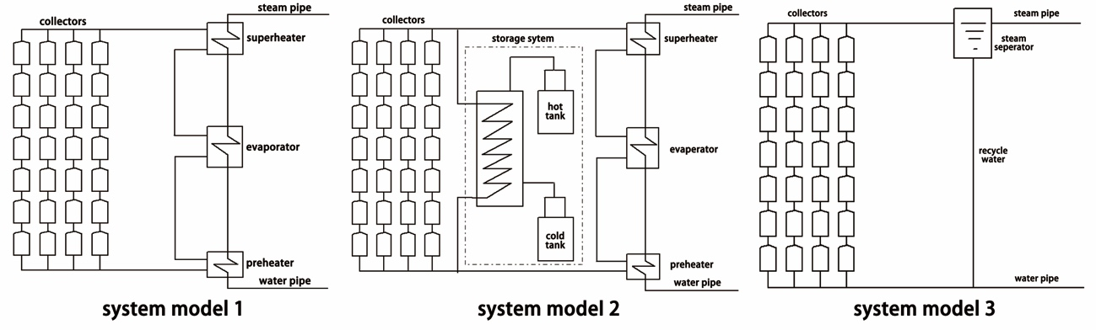

**FIGURE 3. Fundamental principle of the systems**

# Calculation

According to methods mentioned in section *solar radiation* and data in CMA, we can get the simulation data in Fig. 4. Monthly average temperature and wind speed are listed in Table 3.

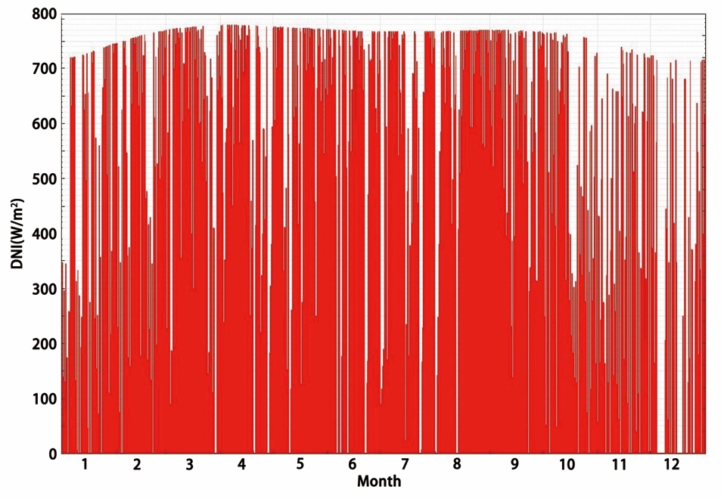

**FIGURE 4.** Simulation results of solar radiation in Karamay

**TABLE 3.** Monthly average temperature (°C) and wind speed (m/s) in Karamay

|  |  |  |  |  |  |
| --- | --- | --- | --- | --- | --- |
| **Month** | **Temperature** | **Wind Speed** | **Month** | **Temperature** | **Wind Speed** |
| 1 | -15.9 | 1.2 | 7 | 27.8 | 4.9 |
| 2 | -12.7 | 1.6 | 8 | 26 | 4.4 |
| 3 | 0.5 | 3.1 | 9 | 19.4 | 4.2 |
| 4 | 12.5 | 4.8 | 10 | 9.6 | 3.6 |
| 5 | 20.2 | 5.2 | 11 | -1.4 | 2.4 |
| 6 | 25.7 | 5.3 | 12 | -11.6 | 1.3 |

LS-2 type trough collector is chosen as the collector. Its important parameters can be obtained as in Table 4.

|  |  |  |  |  |  |  |  |  |  |  |  |  |  |  |  |  |  |  |  |  |  |  |  |  |  |  |  |  |  |  |  |  |  |  |  |  |  |  |  |  |  |  |  |  |  |
| --- | --- | --- | --- | --- | --- | --- | --- | --- | --- | --- | --- | --- | --- | --- | --- | --- | --- | --- | --- | --- | --- | --- | --- | --- | --- | --- | --- | --- | --- | --- | --- | --- | --- | --- | --- | --- | --- | --- | --- | --- | --- | --- | --- | --- | --- |
| **TABLE 4.** Parameters of the collector   |  |  | | --- | --- | | **Parameter** | **Value** | | *L* | 50m | | *W* | 5m | | *A* | 235m2 | | *f* | 1.8m | | *α0* | 1 | | *α1* | 0.000884 | | *α2* | -0.00005369 | | *ηtrack* | 0.99 | | *ηgeo* | 0.98 | | *ηmirror* | 0.935 | | *ηopt,peak* | 0.8285 | | *ηopt,av* | 0.7391 | | **TABLE 5.** Parameters of the receiver   |  |  | | --- | --- | | **Parameter** | **Value** | | Absorber inner diameter | 0.066m | | Absorber outer diameter | 0.07m | | Envelope inner diameter | 0.115m | | Envelope outer diameter | 0.12m | | Absorber material | 304L | | Absorber absorptivity | 0.96 | | Envelop absorptivity | 0.02 | | Envelop transmissivity | 0.963 | |

PTR70 type receiver is chosen as the receiver. Its important parameters can be obtained as in Table 5.

According to the parameters of receiver and environment, typical value of the parameters in Equ. 8~15 can be obtained and listed in Table 6.

**TABLE 6.** Parameters of receiver and environment

|  |  |  |  |  |  |
| --- | --- | --- | --- | --- | --- |
| **Parameter** | **Value** | **Parameter** | **Value** | **Parameter** | **Value** |
| *a0* | 1.8615 | *a4* | 8.8034E-8 | *Tamb* | 8.4℃ |
| *a1* | 1.8741E-1 | *a5* | -9.1215E-1 | *uwind* | 3.5m/s |
| *a2* | -1.1594E-3 | *a6* | 1.1763E-2 | *Tin* | 200℃ |
| *a3* | 6.6026E-8 | *FHL* | 1.25 | *Tout* | 363℃ |

For dual-loop system, Dowtherm A is chosen as the HTF. For heat storage, dual tank technology is used and solar salt (60% NaNO3 and 40% KNO3) is chosen as thermal storage medium.

For cost analysis, the solar thermal oilfield steam production system cost is divided to two parts: direct investment and indirect investment. The direct investment is composed of several parts:

• Building project investment

• Collector field investment

• Heat exchanger system investment

• Heat storage system investment

• HTF investment

The direct investment of the system can be estimated by existing commercial solar power plants. Table 7 shows the cost items of the steam production system.

**TABLE 7.** Cost items of the steam production systems

|  |  |
| --- | --- |
| **Cost Items** | **Cost** |
| Building Project | $ 13.5/m2(collector field) |
| Absorber | $ 43/m2(collector field) |
| Mirror | $ 40/m2(collector field) |
| Collector structure | $ 50/m2(collector field) |
| Collector assemble | $ 17/m2(collector field) |
| Collector drivers | $ 13/m2(collector field) |
| Connecting lines | $ 11/m2(collector field) |
| Electrical and control | $ 16/m2(collector field) |
| Others (spare parts, freight) | $ 17/m2(collector field) |
| Receiver system | $ 250/m2(collector field) |
| Heat exchanger system | $ 23/m2(collector field) |
| Heat storage system | $ 31.4/kWh |

The indirect investment includes:

• Regular check and maintenance

• Renew and replacement of the equipment

• Staff expense

• Cleaning of the field

The indirect investment various with local labor cost and local resources cost (such as water). In the models, the indirect investment reference the value given by NERL, which is $ 50kWe/a by unit power or $ 2.73t/a by steam evaporation rate.

It is worth pointing that the cost analysis did not take consideration of the water treatment and instrument control cost because of lack of data.

# Results and conclusions

According to the 3 types of system, models of different plans with different steam pressures, different degrees of superheat are built and calculated. The collector field areas of different plans are obtained and shown in Fig. 5-7.

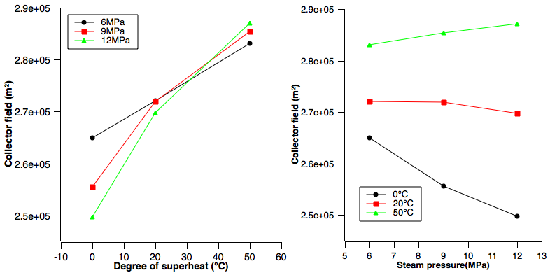

**FIGURE 5.** Collector field area of system 1

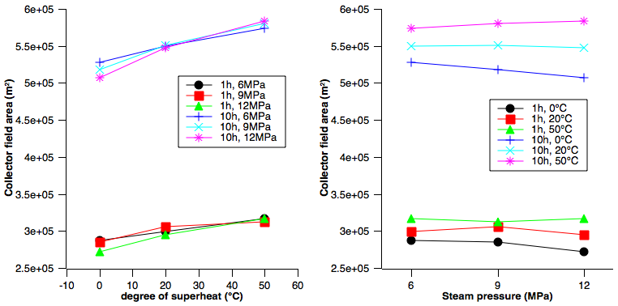

**FIGURE 6.** Collector field area of system 2

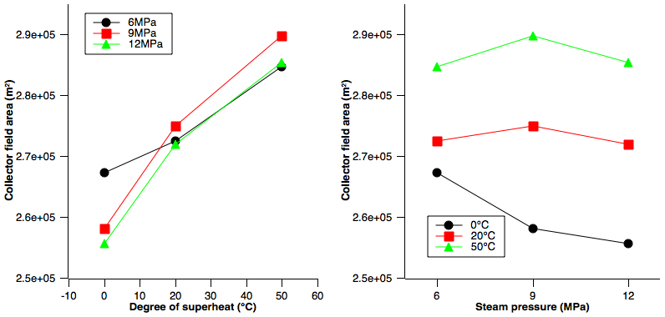

**FIGURE 7.** Collector field area of system 3

From Fig. 5-7, it is clear that with fixed steam pressure, collector field area increases with degree of superheat. But with fixed degree of superheat, collector field area has no clear relationship with steam pressure.

Assume the service life of the systems to be 20 years, according to the cost estimation method, cost of different plans can be obtained and cost of unit generated steam can be calculated.

Some typical results (*p* = 9MPa, *∆T* = 0°C) are listed in Table 8.

**TABLE 8.** Cost of typical systems

|  |  |  |  |
| --- | --- | --- | --- |
| **System Model** | **Heat Storage (h)** | **Total Cost ($)** | **Unit Generated Steam Cost ($)** |
| System 1 |  | 8296.6 | 15.61 |
| System 2 | 1 | 8959.89 | 14.98 |
| System 2 | 5 | 12341.39 | 14.29 |
| System 2 | 10 | 18207.15 | 15.22 |
| System 3 |  | 7829.47 | 14.6 |

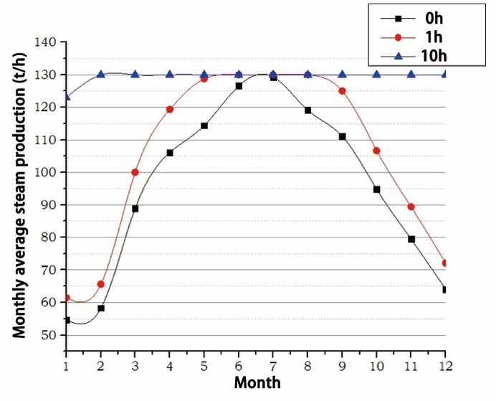

**FIGURE 8.** Steam production of different plans

From Fig. 8, it can be concluded that without storage, the steam production varies greatly in different months, high production in summer and low production in winter. With the increase of heat storage, the continuous production time increased. When the storage time reaches 10h, each month average steam production remains at the design value, which can satisfy the requirements of the heavy oil production.

This paper discusses the feasibility and economical of solar thermal oilfield steam production system plan. A method to estimate a city’s solar radiation data using known solar radiation data of surrounding cites is used. Several models including different solar thermal technologies, different heat storage capacities are built and compared. It is clear that using heat storage can effectively improve the stability of solar steam production. Calculation results show that dual-loop with 5 hour heat storage is the best plan for least steam cost. And it is also possible to achieve low steam cost with DSG plan, although now as a backup plan for the consideration of safety and feasibility. It needs deep research for its simplicity and directness for steam production.

# References

1. Lupfert E，Geyer M，Schiel W，et a1. “Eurotrough Design Issues and Prototype Testing at PSA”[C].Proc. of ASME Int. Solar Energy Conference - Forum 2001, Washington DC, 2001, 389–394.
2. Hany Al-Ansary, O.Zeitoun. “Numerical study of conduction and convection heat losses from a half-insulated air-filled annulus of the receiver of a parabolic trough collector”[J].Solar Energy.85(2013)3036-3045.
3. Ricardo Vasquez Padilla, Gokmen Demirkaya,et al. “Heat transfer analysis of parabolic trough solar receiver”[J].Applied Energy.88(2013)5097–5110.
4. Forristall R. “Heat Transfer Analysis and Modeling of a Parabolic Trough Solar Receiver Implemented in Engineering Equation Solver”[R].NREL, 2003.
5. M.J.Montesa A A J M. “Solar multiple optimization for a solar-only thermal power plant using oil as heat transfer fluid in the parabolic trough collectors”[J].Solar Energy.83(2009) 2165-2176.
6. Dudley V E. “Test Results SEGS LS-2 Solar Collector”[R].SAND,1994.